**Lab# 5 Tasks**

**Abbas Shafi**

1. Write a program to print multiplication table of a given number using for loop.

**Program:**

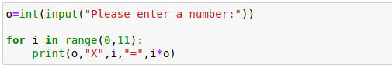

**Output:**

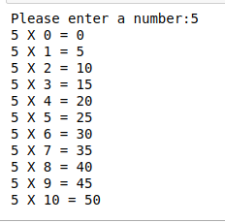

2. Write a program to greet all persons names stored in a list.

person=[“name”, “name”, “name”, “name”]

**Program:**

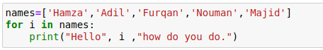

**Output:**

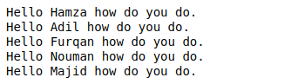

3. Attempt problem 1 using while loop.

**Program:**

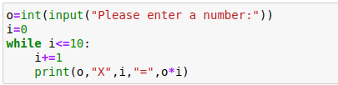

**Output:**

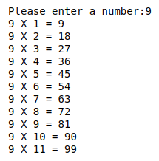

4. Write a program to find whether the given number is prime or not.

**Program:**

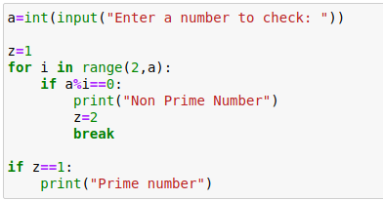

**Output:**



5. Write a program to print sum of numbers in a list.

**Program:**

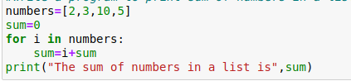

**Output:**



6. Write a program to print sum of natural numbers entered by user using while loop.

**Program:**

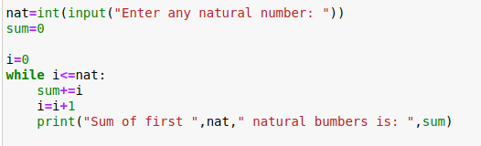

**Output:**

